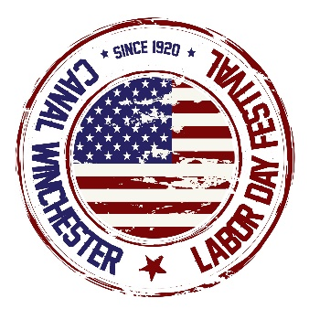
Canal Winchester 2026 Labor Day Festival
Sponsorship Opportunities

Main Stage Sponsor - $8,000
- Recognized throughout the festival in all announcements as sponsor of Main Stage.
- Video/audio commercial – main stage LED screen.
- Link to your website from our festival website.
- Corporate banners prominently displayed during festival.
- Social media mention as sponsor.
- Space provided on street for a company information booth for your business if desired. (You provide the 10 x 10 tent ).
- Free parade entry.

Free Ride Saturday - $5,000
- Recognized throughout the festival in all announcements as sponsor of ‘Free Ride Saturday’.
- Video/audio commercial – main stage LED screen.
- Link to your website from our festival website.
- Social media mention as sponsor.
- Space provided on street for a company information booth for your business if desired. (You provide the 10 x 10 tent ).
- Free parade entry.

Inflatables Sponsor - $5,000
- Recognized throughout the festival in all announcements as sponsor.
- Video/audio commercial – main stage LED screen.
- Banner prominently displayed in Kids’ Zone.
- Link to your website from our festival website.
- Social media mention as sponsor.
- Space provided on street for a company information booth for your business if desired. (You provide the 10 x 10 tent ).
- Free parade entry.

Tail Gate Sponsor - $3,000
- Video/audio commercial – main stage LED screen.
- Company name included in all announcements throughout the event.
- Social media mention as sponsor.
- Link to your website from our festival website.
- Free parade entry.
- Space provided on street for a company information booth for your business (You provide the 10 x10 tent )

Gaming Trailer Sponsor - $2,000
- Recognized throughout the festival in all announcements as sponsor.
- Link to your website from our festival website.
- Recognition on social media.
- Banner/sign at trailer location.
- Company name/logo on LED screen.
- Space provided on street for a company information booth for your business (You provide the 10 x10 tent )
- Free parade entry.

Information Booth Sponsor - $1,500
- Banner hung at information booth/first aid station
- Link to your website from our festival website.
- Social media mention as sponsor.
- Prominent space provided on street for a company information booth for your business if desired. (You provide the 10 x 10 tent).
- Company name/logo on LED screen.
- Free parade entry.

The Raptor Road Show - $1,000
- Company name mentioned in all announcements throughout the event.
- Banner prominently at Raptor Road Show location.
- Link to your website from our festival website.
- Company name/logo on LED screen
- Free parade entry

Dining Tent Sponsor – $500/each or Exclusive for $1,500
- Banner/sign on all three dining tents (you provide)
- Company name mentioned in all announcements throughout the event.
- Link to your website from our festival website.
- Company name/logo on LED screen if you sponsor all three
- Recognized in all promotional materials.
- Space provided on street for a company information booth for your business (You provide the 10 x10 tent ) if you sponsor all three

Festival Partner - $1,000
- Company name mentioned in all announcements throughout the event.
- Banner prominently at Stradley Stage.
- Link to your website from our festival website.
- Company name/logo on LED screen.
- Free parade entry.

Friends of the Festival - $250 each
- 18” x 24” sign on Friends of the Festival Wall
- Company name mentioned in all announcements throughout event.

*All promotional materials must be submitted by August 1 to comply with print deadlines

